AI LAB 3

21K-3153

TASK 1:

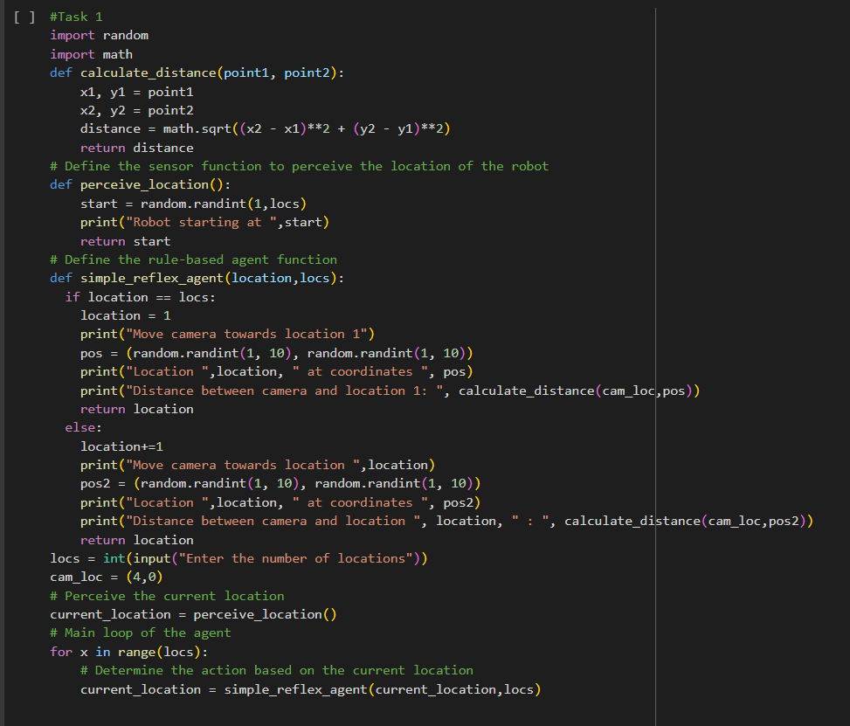

TASK 2:

Task 3:

Task 4:

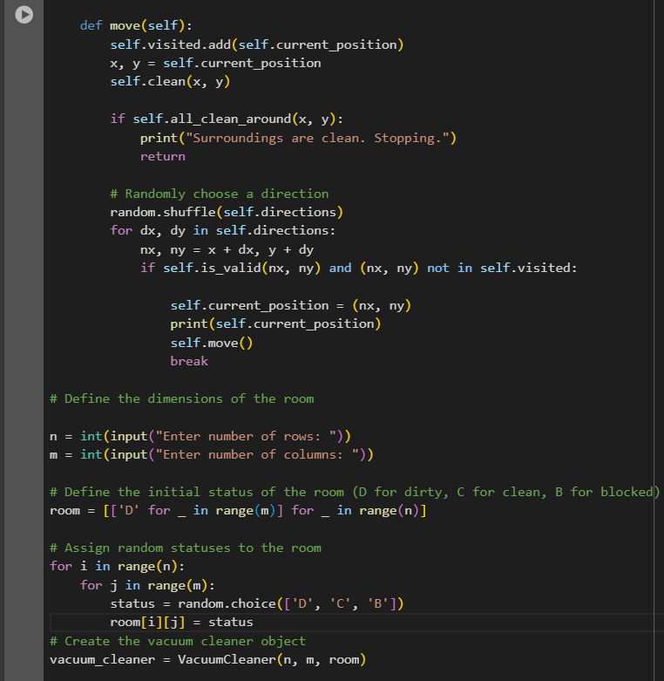

Welcome to Tic Tac Toe!

| |

-----

| |

-----

| |

-----

Enter row (0, 1, or 2): 2

Enter column (0, 1, or 2): 2

| |

-----

| |

-----

| |X

-----

Computer's move:

O| |

-----

| |

-----

| |X

-----

Enter row (0, 1, or 2): 1

Enter column (0, 1, or 2): 2

O| |

-----

| |X

-----

| |X

-----

Computer's move:

O| |O

-----

| |X

-----

| |X

-----

Enter row (0, 1, or 2): 0

Enter column (0, 1, or 2): 1

O|X|O

-----

| |X

-----

| |X

-----

Computer's move:

O|X|O

-----

| |X

-----

|O|X

-----

Enter row (0, 1, or 2): 1

Enter column (0, 1, or 2): 1

O|X|O

-----

|X|X

-----

|O|X

-----

Computer's move:

O|X|O

-----

O|X|X

-----

|O|X

-----

Enter row (0, 1, or 2): 2

Enter column (0, 1, or 2): 0

O|X|O

-----

O|X|X

-----

X|O|X

-----

It's a draw!

Task 6:

